Final Report
HBL Banking API

Group Members:
Junaid Afzal — L1S23BSSE0001
Qaim Raza — L1S23BSSE0016
Abdullah Askari — L1S23BSSE0037
M Afnan Raees — L1S23BSSE0024

Technologies Used
- Node.js
- Express.js
- MongoDB
- Mongoose
- Cloudinary
- Redis
- Swagger
- Postman

Entity Relationship Diagram (ERD)

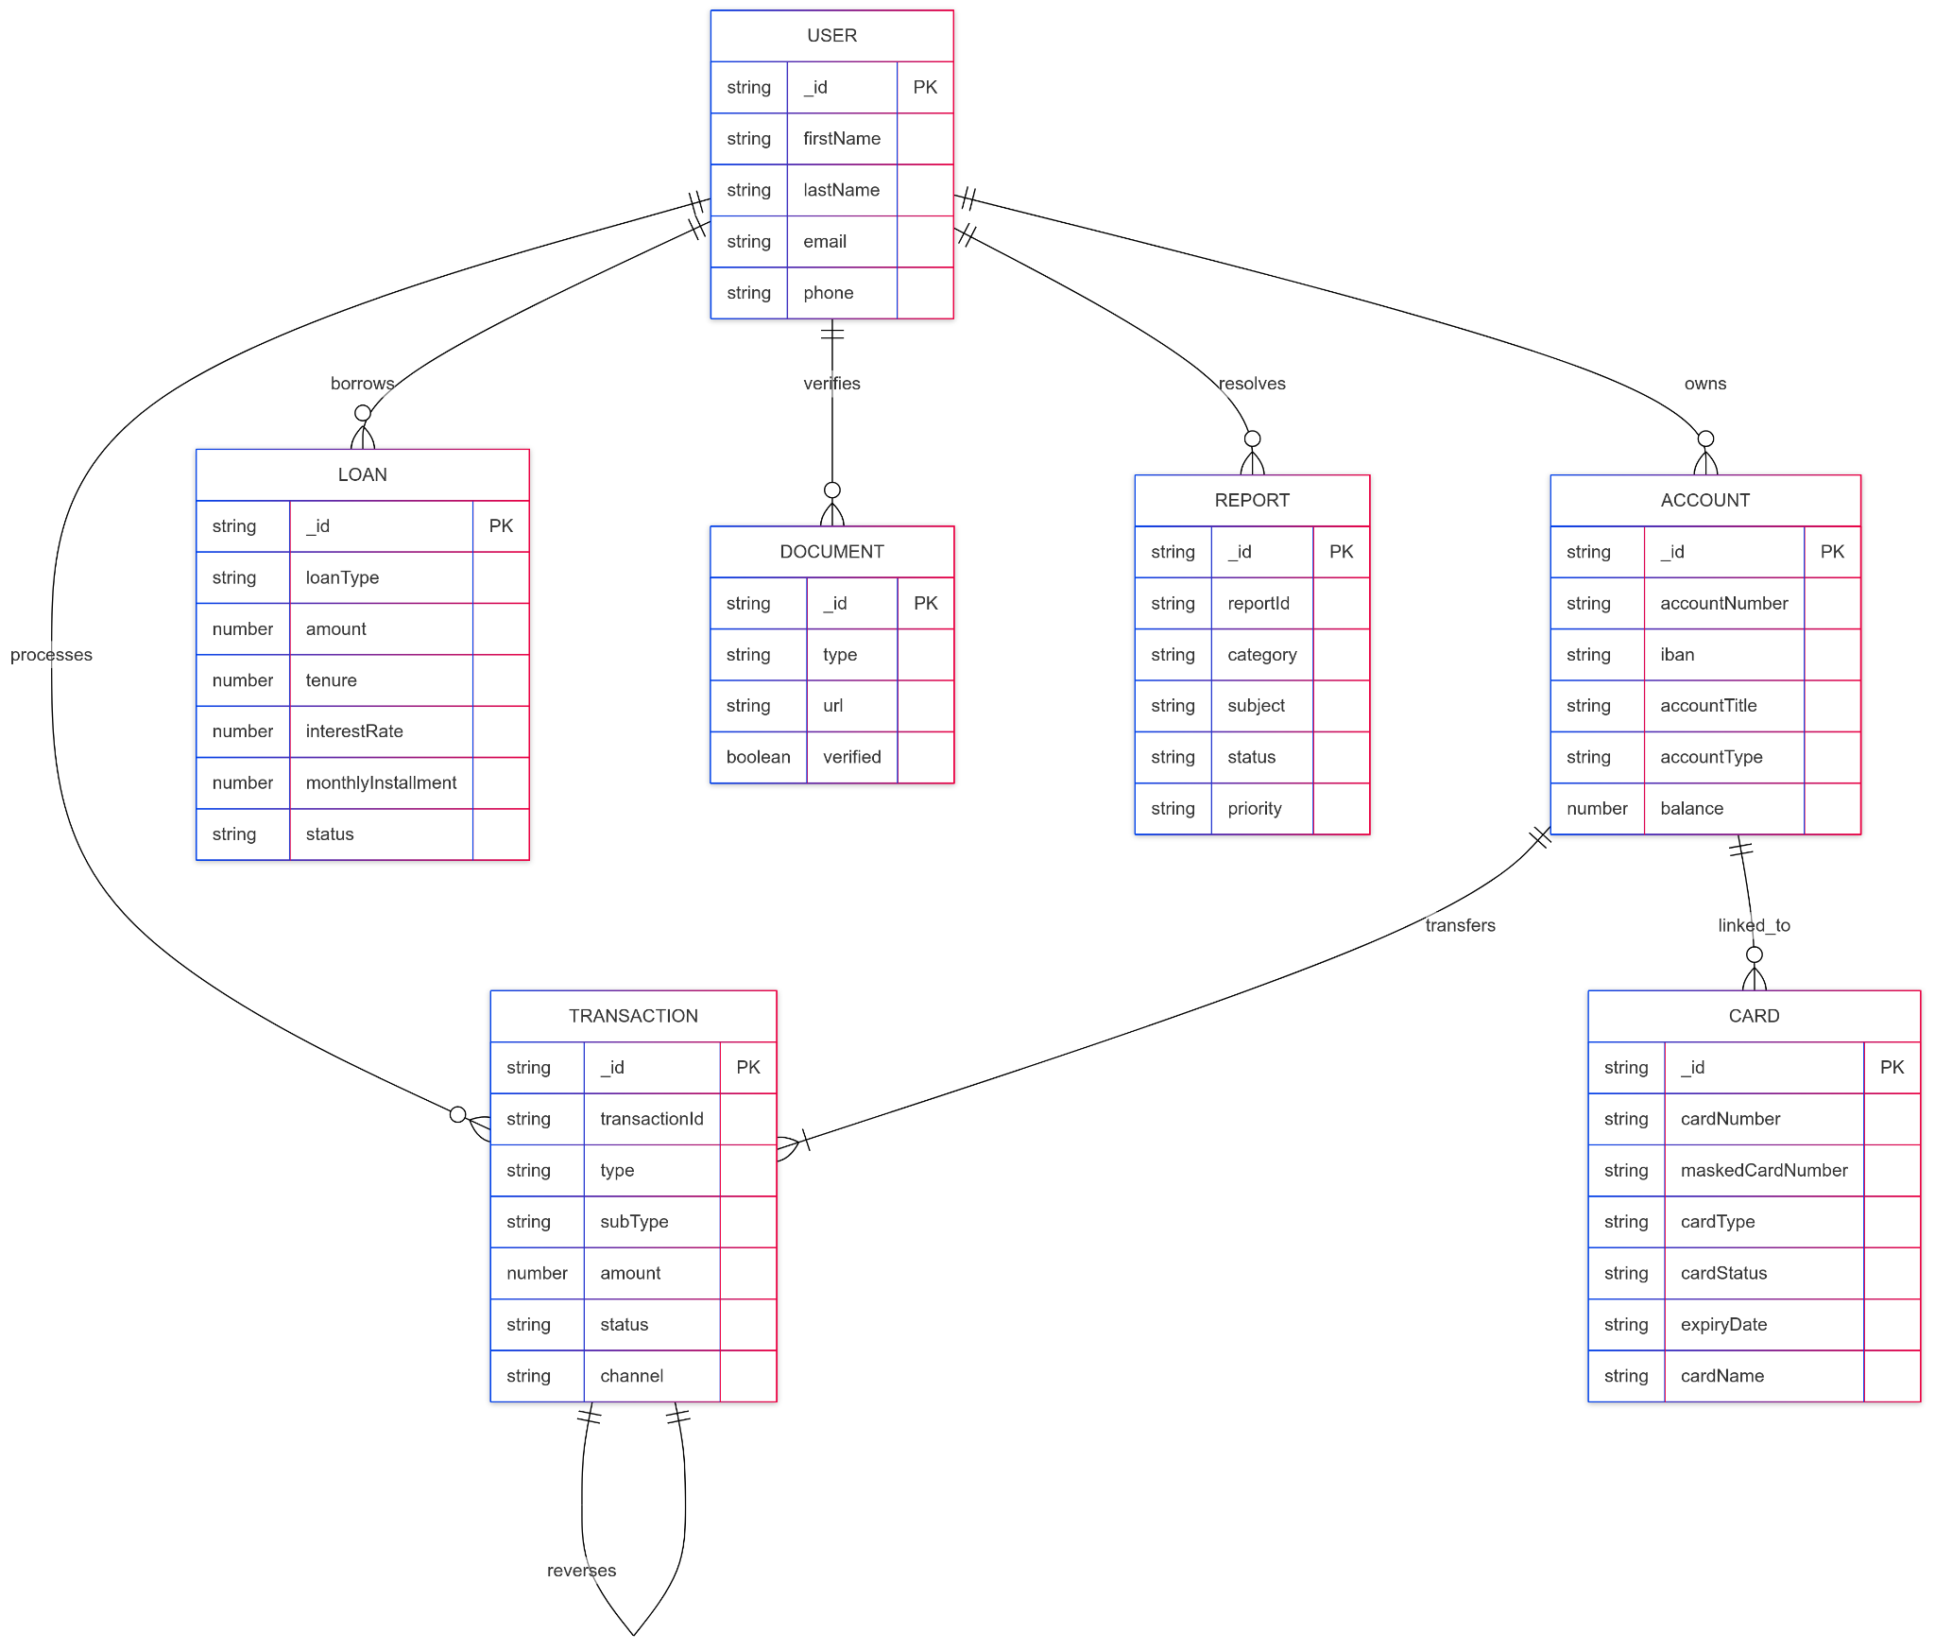

API Endpoints
Route | Method | Description
/api/auth/register | POST | Register a new user
/api/auth/login | POST | Authenticate user and issue token
/api/accounts | GET | Retrieve all user accounts
/api/accounts/:id | GET | Retrieve account details by ID
/api/transactions | POST | Create a transaction (transfer/payment)
/api/transactions/:id | GET | Get transaction details
/api/loans | POST | Apply for a loan
/api/loans/calculate | POST | Calculate loan EMI
/api/cards | POST | Request a new card
/api/notifications | GET | Get user notifications
/api/admin/stats | GET | View admin dashboard statistics
Complete Endpoint details in the Readme file

Challenges Faced
- Integrating multiple third-party services (Cloudinary, Redis)
- Designing a scalable and secure schema
- Implementing robust authentication and authorization
- Handling edge cases and errors in API endpoints
- Learning to use Swagger and Postman for API documentation

Learnings
- Improved understanding of RESTful API design and best practices
- Hands-on experience with MongoDB and Mongoose for schema design
- Practical knowledge of middleware, error handling, and logging
- Experience with API documentation tools and testing workflows

